Website Analysis Project

Getting straight to the point the [Simbiotech’s website](http://www.simbiotech.com/index.php) is the victim of my objective judgment. We will discuss how nice to the eye and generally usable it is and generously make some corrections in case it fails on the following points.

**Usability**

Let's pretend I'm a person in trouble who desperately needs medical equipment for my fancy private clinic. First of all, if my soul hadn't led me to the right place, it would have taken me a while to figure out what the company that owns this site does and I would have lost the thread of the story pretty quickly. The navigation in it is quite strange, you look at the phone numbers listed, in an obvious place, which is quite good, but after five minutes spent on the site you realize that a phone call is your only way out not only to interact with the seller, but also to get basic information, because all other links and points of interest on the site (which for some reason are repeated randomly) lead to a dead end or to other independent sources.

The website is in no way adapted for users with disabilities, but has its own translation into English in two WHOLE sections on the page : “About us” and “Contacts”, it is tough and it probably proves that the rest of the information on the site is basically…

**Design**

In terms of design, I'd say it's something vague. It's as if someone was asked to quickly build a page with minimal requirements, and not having knowledge of basic site structure, would have to reciprocate other site's elements, lazily implementing them and then just throwing some of own solutions wherever there is space, without thinking about aesthetic value or company identity. Many elements do not have a logical position, they repeat multiple times without any purpose and at the same time the distinction between the text is very unclear. Font and text size are not always stylistically uniform, but does not interfere perception.



Note : The object of my nightmares.

**Responsiveness**

In fact, I would even say, that the mobile version of the site looks and can be used at times better than its computer implementation. From a visual point of view not quite pleasant location of elements became less visible, the site itself does not look like a pile of unnecessary details and besides the problems with the size and arrangement of images (common for all versions) I would say that the site is better adapted for mobile users.

**Performance**

Using PageSpeed Insights the readings are quite comforting. Despite the fact that the mobile version seems to be more pleasant to use, it is much less efficient in downloading content. The PC version of the site shows good performance (probably, obviously, it must be hard to boot the system with a small prickly fine content, however clumsy it was not introduced). From what spoils the picture can be highlighted: outdated image formats and their code implementation and size.

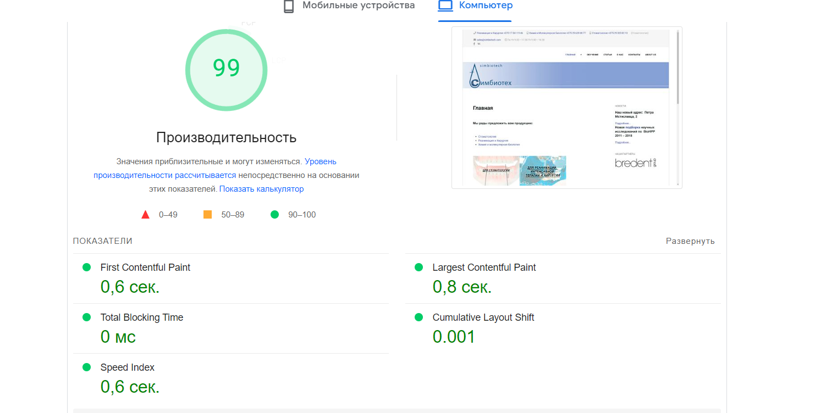

Performance on PC according to PageSpeed Insights.

**Search Engine Optimization (SEO)**

Based on the data from the service from the previous item we can conclude that the search engine is well optimized. The site has the necessary elements, meta keywords such as "Symbiotech", "Minsk", "Belarus", a clear internal linking structure with navigation menus and links within the content, link descriptions, so I have no complaints.

**Additional Considerations**

Based on the target audience, which is health facilities or individuals who wish to take courses most likely, it would be wise to consider that the main purpose of the site is to bring a prolific and current information to the buyer about the options for purchase, so that the user would last have to contact the vendor directly or search for product information somewhere else. And in general, the approach in the industry is to be a independent island with its ecosystem and instantly provide the user with all the necessary information for subsequent co-workering.

How to fix all that?

We have a long way to go. The main priority is to work on the visual part and navigation, remove superfluous elements and correct the position/size of existing, logically separate blocks of pages and admire the result. On deeper levels, the site requires an impressive upgrade, it should actively position itself as a point of immersion in the indexing of its product, be self-contained and stylistically complete to fit the standards of the modern world.

But what could I do? Technically , judging by the performance test, I was completely satisfied with it. My main problem was two things:

Visual.

The user/buyer experience.

The latter implies that in a perfect world, a site like this would be a full-fledged platform for browsing products, rather than just being a tool to find a company number. And with that, I didn't find anything I could do with my resources. So I focused on the visuals, after many hours of trying to figure out the code assets,frustration, trying to write the site from scratch, after another frustration I decided to make minor changes to the original code just to guide its development. Namely :

Working with Colors :

Color structure is very important to the aesthetic feel of the site, one of the most popular methods of balancing colors is to repeat them to form a full color scheme, I extracted colors from basic elements like the logo and incorporated them into the rest of the elements where appropriate.

Removal of redundancies :

Something had to be removed to make the site visually lighter, one of the first sacrifices was the translation of “About Us” and “Contact Us”, not being a fan of half measures I think it's better to be able to switch the language completely if you are dealing with English speaking clients.

Transfer :

The contact line was moved to the footer, of course, in the current state of the site it is more of a loss, because the direct call is still the easiest way to get the information you need. But setting the line of development of the site, it itself should be quite independent in this.

The images in the main part of the page have been removed. In my head this section should look different, here the images are inserted as if they are flush against each other, which looks rather lazy. A better solution would be to replace this with small animated blocks in the center. I couldn't do that (apparently there are clear position settings in one of the assets), but I implemented a temporary draft solution.

That's all for now. Changes were made only for the main page, but on the rest of the principle would remain the same: correction of questionable position of elements, colors, removal of images.

[FIXEDWEB-SITE](https://github.com/CaroLAlrd/Web-Dev-Stepanenko-Report/blob/main/www.simbiotech.com/fixedindex.html)